Ex. No: 12
Date:16.04.2025

File Organization Technique- Single and Two level directory

AIM:
To implement File Organization Structures in C are a. Single Level Directory
- Two-Level Directory
- Hierarchical Directory Structure
- Directed Acyclic Graph Structure

a. Single Level Directory
ALGORITHM:
- Start
- Declare the number, names and size of the directories and file names.
- Get the values for the declared variables.
- Display the files that are available in the directories.
- Stop.

PROGRAM:
#include <stdio.h> #include <string.h> struct Directory { char name[10][20]; int count;
}; int main() { struct Directory dir; dir.count = 0; int n;
printf("Enter the number of files: ");
scanf("%d", &n);
for(int i = 0; i < n; i++) {
printf("Enter the name of file %d: ", i + 1); scanf("%s", dir.name[i]); dir.count++;
} printf("\nFiles in the directory:\n"); for(int i = 0; i < dir.count; i++) { printf("%s\n", dir.name[i]);
} return 0;
}
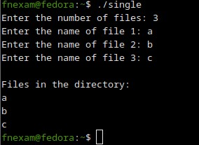
b. Two-level directory Structure
ALGORITHM:
- Start
- Declare the number, names and size of the directories and subdirectories and file names.
- Get the values for the declared variables.
- Display the files that are available in the directories and subdirectories.
- Stop.

PROGRAM:
#include <stdio.h>
#include <string.h>

struct SubDirectory { char files[10][20]; int file_count;
};
struct Directory { char dir_name[20]; struct SubDirectory subdirs[10]; int subdir_count;
};

int main() { struct Directory dir; printf("Enter Directory Name: "); scanf("%s", dir.dir_name);
printf("Enter the number of subdirectories: ");
scanf("%d", &dir.subdir_count);

for(int i = 0; i < dir.subdir_count; i++) { printf("\nSubdirectory %d:\n", i + 1); printf("Enter number of files: "); scanf("%d", &dir.subdirs[i].file_count); for(int j = 0; j < dir.subdirs[i].file_count; j++) { printf("Enter file %d name: ", j + 1); scanf("%s", dir.subdirs[i].files[j]);
}
}

printf("\nDirectory Structure:\n"); printf("Directory: %s\n", dir.dir_name); for(int i = 0; i < dir.subdir_count; i++) { printf(" Subdirectory %d Files:\n", i + 1); for(int j = 0; j < dir.subdirs[i].file_count; j++) { printf("%s\n", dir.subdirs[i].files[j]);
}
}

return 0;
}

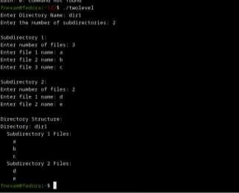

RESULT:
Hence, file organization technique has been executed successfully.

